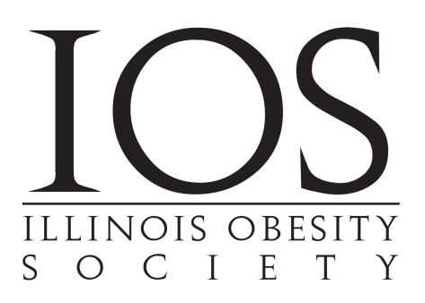

Please RSVP to [admin@IllinoisObesitySociety.org](mailto:admin@IllinoisObesitySociety.org)

IOS members - Free Non-members - $50

**6:00pm Networking and Cocktails  
7:00pm Presentation and Dinner**

Come join your colleagues for:  
**"Motivational Interviewing: A tool to Improve Communication with Non-Adherent Patients"**  
**Andrea Busby, PhD**  
Assistant Professor, Department of Psychiatry and Behavioral Neuroscience, University of Chicago

University of Illinois, Chicago

Wednesday, January 23rd   
**Gene & Georgetti**  
9421 W. Higgins Rd, Rosemont IL 60018

To promote the practice of Obesity Medicine by providing opportunities for local obesity specialists to network, share best practices, and educate the medical community and the public about the disease of Obesity.  
**Open to MD/DO/NP/PA/RD/PsyD/PhD**

WE CORDIALLY INVITE YOU TO OUR FALL EVENT